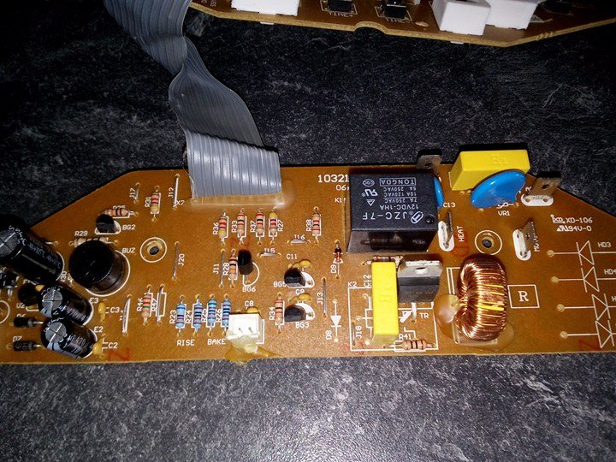
RELAIS
RESISTANCE

